Laboratory Screening Questions

Date: _____________ Subject Number: ________________

Age: ______ Sex: Male ___ Female ___

Race: (check the most appropriate group or groups)

___ 1. African American
___ 2. American Indian
___ 3. Hispanic
___ 4. White (Caucasian)
___ 5. Other
(Please Specify)
Which Racial or Ethnic group do you most identify yourself as? ____________________

What is your current marital status? ______________

How many times have you been married or lived with someone as though married? _____

For Smokers Only
I smoke or use smokeless tobacco on a regular basis? ___ Yes ___ No
On an average day, I smoke ___ cigarettes, ___ cigars or have ___ dips of tobacco.
(how many?) (how many?) (how many?)
I started smoking on a regular basis when I was ____ years old.
I have experienced health related problems because of smoking. ___ Yes ___ No
How long ago was your last tobacco use? __ minutes __ hours __ days __ years
(how many?) (how many?) (how many?) (how many?)

How many years of school have you COMPLETED?
GED = 12 years
include technical training
add 1 year for every 30 college hours completed

What kind of work do you normally do?

For Office Use Only:
TESTING START TIME = ______________ CO = ______________ TIME = ______________

Screened by: ______________ Scored by: ______________ Checked by: ______________

FAMILY HISTORY DRINKING OR DRUG USE

N = NEVER S = SOCIAL A = ALCOHOL D = DRUG AD = ALCOHOL & DRUGS

DK = DON’T KNOW (If you have no knowledge of a relative)

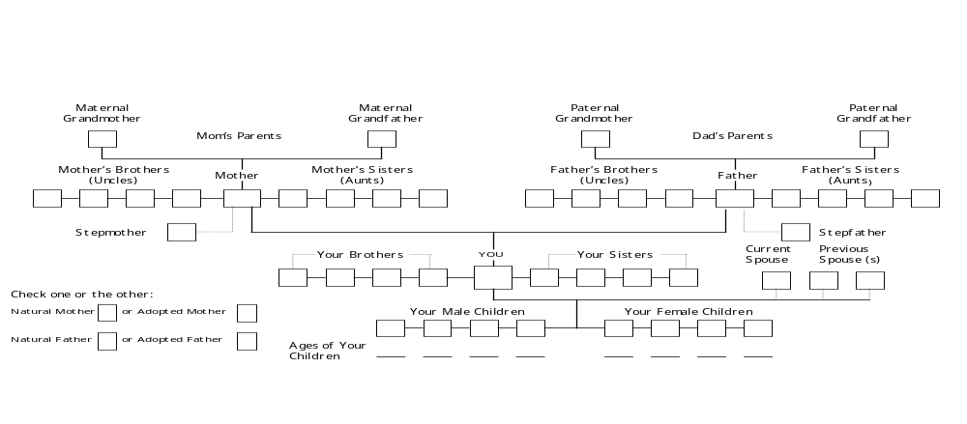

SELF-EVALUATION FORM
STAI Form Y-1

Directions: A number of statements which people have used to describe themselves are given below. Read each statement and then circle the appropriate number to the right of the statement to indicate HOW YOU FEEL GENERALLY. There are no right or wrong answers. Do not spend too much time on any one statement, but give the answer that seems to describe your present feelings best.

Not Somewhat Moderately Very
at all so much so

1. I feel calm 1 2 3 4

2. I feel secure 1 2 3 4

3. I am tense 1 2 3 4

4. I feel strained 1 2 3 4

5. I feel at ease 1 2 3 4

6. I feel upset 1 2 3 4

7. I am presently worrying over possible misfortunes 1 2 3 4

8. I feel satisfied 1 2 3 4

9. I feel frightened 1 2 3 4

10. I feel comfortable 1 2 3 4

11. I feel self-confident 1 2 3 4

12. I feel nervous 1 2 3 4

13. I am jittery 1 2 3 4

14. I feel indecisive 1 2 3 4

15. I am relaxed 1 2 3 4

16. I feel content 1 2 3 4

17. I am worried 1 2 3 4

18. I feel confused 1 2 3 4

19. I feel steady 1 2 3 4

20. I feel pleasant 1 2 3 4

BDI-II

Instructions: Choose ONE statement in each group that BEST describes the way you have been feeling during the LAST TWO WEEKS, including today. Circle the number beside the statement you have picked. If several statements seem to apply equally well, circle the highest number for that group. If none of the items seem to apply, circle 0. Be sure not to choose more than one statement for any group, including Item 16 (Changes in Sleeping Pattern) or Item 18 (Changes in Appetite).

1. Sadness | 7. Self-Dislike
0 I do not feel sad. | 0 I feel the same about myself as ever.
1 I feel sad much of the time. | 1 I have lost confidence in myself.
2 I am sad all the time. | 2 I am disappointed in myself.
3 I am so sad or unhappy I can’t stand it. | 3 I dislike myself.
2. Pessimism | 8. Self-Criticalness
0 I am not discouraged about my future. | 0 I don’t criticize or blame myself more than usual.
1 I feel more discouraged about my future than | 1 I am more critical of myself than I used to be.
I used to be. | 2 I criticize myself for all of my faults.
2 I do not expect things to work out for me. | 3 I blame myself for everything bad that happens.
3 I feel my future is hopeless and will only
get worse. | 9. Suicidal Thoughts or Wishes
 | 0 I don’t have any thoughts of killing myself.
3. Past Failure | 1 I have thoughts of killing myself, but I would
0 I do not feel like a failure. | not carry them out.
1 I have failed more than I should have. | 2 I would like to kill myself.
2 As I look back, I see a lot of failures. | 3 I would kill myself if I had the chance.
3 I feel I am a total failure as a person.
 | 10. Crying
4. Loss of Pleasure | 0 I don’t cry anymore than I used to.
0 I get as much pleasure as I ever did from | 1 I cry more than I used to.
the things I enjoy. | 2 I cry over every little thing.
1 I don’t enjoy things as much as I used to. | 3 I feel like crying, but I can’t.
2 I get very little pleasure from the things
I used to enjoy. | 11. Agitation
3 I can’t get any pleasure from the things I | 0 I am no more restless or wound up than usual.
used to enjoy. | 1 I feel more restless or wound up than usual.
 | 2 I am so restless or agitated that it’s hard
5. Guilty Feelings | to stay still.
0 I don’t feel particularly guilty. | 3 I am so restless or agitated that I have to
1 I feel guilty over many things I have done or | keep moving or doing something.
should have done.
2 I feel quite guilty most of the time. | 12. Loss Of Interest
3 I feel guilty all of the time. | 0 I have not lost interest in other people or
 | activities.
6. Punishment Feelings | 1 I am less interested in other people or things
0 I don’t feel I am being punished. | than before.
1 I feel I may be punished. | 2 I have lost most of my interest in other people
2 I expect to be punished. | or things.
3 I feel I am being punished. | 3 It’s hard to get interested in anything.
BDI-II

13. Indecisiveness | 18. Changes in Appetite
0 I make decisions about as well as ever. | 0 I have not experienced any change in my
1 I find it more difficult to make decisions | appetite.
than usual. | 1a My appetite is somewhat less than usual.
2 I have greater difficulty in making decisions | 1b My appetite is somewhat greater than usual.
than I used to. | 2a My appetite is much less than before.
3 I have trouble making any decisions. | 2b My appetite is much greater than usual.
 | 3a I have no appetite at all.
14. Worthlessness | 3b I crave food all the time.
0 I do not feel I am worthless.
1 I don’t consider myself as worthwhile or | 19. Concentration Difficulty
useful as I used to. | 0 I can concentrate as well as ever.
2 I feel more worthless as compared to | 1 I can’t concentrate as well as usual.
other people. | 2 It’s hard to keep my mind on anything
3 I feel utterly worthless. | for very long.
 | 3 I find I can’t concentrate on anything.
15. Loss of Energy
0 I have as much energy as ever. | 20. Tiredness or Fatigue
1 I have less energy than I used to have. | 0 I am no more tired or fatigued than usual.
2 I don’t have enough energy to do very much. | 1 I get more tired or fatigued more easily
3 I don’t have enough energy to do anything. | than usual.
 | 2 I am too tired or fatigued to do a lot of the
16. Changes in Sleeping Pattern | things I used to do.
0 I have not experienced any change in my | 3 I am too tired or fatigued to do most of the
sleeping pattern. | things I used to do.
1a I sleep somewhat more than usual.
1b I sleep somewhat less than usual. | 21. Loss of Interest in Sex
2a I sleep a lot more than usual. | 0 I have not noticed any recent change in my
2b I sleep a lot less than usual. | interest in sex.
3a I sleep most of the day. | 1 I am less interested in sex than I used to be.
3b I wake 1-2 hours early and can’t get back | 2 I am much less interested in sex now.
to sleep. | 3 I have lost interest in sex completely.
17. Irritability
0 I am no more irritable than usual.
1 I am more irritable than usual.
2 I am much more irritable than usual.
3 I am irritable all the time.

ALCOHOL USE QUESTIONNAIRE

How old were you when you:

Took your first drink of alcohol (even if it was given to you as a child)?
First got drunk? Began drinking on a regular basis? ____

How many days ago was your last drink?

In the previous six months, how often did you have any kind of beverage containing alcohol, whether it was wine, beer, whiskey, or any other alcoholic drink? Circle the number below that best describes your drinking pattern at that time.

1 = Three or more times a day 6 = Two or three times a month
2 = Twice a day 7 = About once a month
3 = Every day or nearly every day 8 = At least one time in the last 6 months
4 = Three or four days a week 9 = No alcohol at all in the last 6 mo.
5 = One or two days a week

in the previous six months, how often did you typically drink any of the following? Circle one number for each type of alcohol.

WINE | BEER | LIQUOR
1 = EVERY DAY | 1 = EVERY DAY | 1 = EVERY DAY
2 = 5-6 days per week | 2 = 5-6 days per week | 2 = 5-6 days per week
3 = 3-4 days per week | 3 = 3-4 days per week | 3 = 3-4 days per week
4 = 1-2 days per week | 4 = 1-2 days per week | 4 = 1-2 days per week
5 = 3 times /mo or less | 5 = 3 times /mo or less | 5 = 3 times /mo or less
6 = NONE AT ALL | 6 = NONE AT ALL | 6 = NONE AT ALL
On a drinking day, how | On a drinking day, how | On a drinking day, how
much did you typically | much did you typically | much did you typically
drink? (1/5, pint, glass, | drink? (cans, bottles, qts, | drink? (shot, pint, qt,
1/2 gallon, etc.) | 6 pack, 12 pack, etc.) | liter, 1/5, etc.)
How much? ___________ | How much? ___________ | How much? ___________
Typically, I drank: | Typically, I drank: | Typically, I drank:
table wine _____ | 3.2 beer _____ | __________ proof liquor
fortified wine _____ | 6.0 beer _____

CAFFEINE QUESTIONNAIRE

Please answer the following questions for your typical caffeine use during the past thirty days. If you are currently in treatment, please answer for the thirty-day period before you entered treatment.

(1) On an average day, how much of these beverages do you drink?

Circle one below: How many:

Coffee Instant Brewed Drip Cups (5 oz.) ________________
Small mugs (8 oz.) ___________
Large mugs (12 oz.) __________

Tea Instant Brewed Drip Cups (5 oz.) ________________
Small mugs (8 oz.) ___________
Large mugs (12 oz.) __________

Soda Brand (Pepsi, Coke, etc.) Cans (12 oz.) ________________
Bottles:
16 oz. _______________
20 oz. _______________
Liter ________________

(2) On an average day, how much chocolate candy do you eat?

Brand (Snickers, etc.) Amount (# of bars and size)

___________________ ___________________________

-- Continued --

(3) On an average day, how much do you use medications that contain caffeine? See list below for examples.

Brand (Anacin, etc.) Number of pills per day

_________________ __________________

_________________ __________________

Examples of Medications Containing Caffeine

Non-Presciption

Anacin
Dexatrim
Dristan Decongestant
Excedrin
Midol
No Doz
Sinarest
Triaminicin
Vanquish
Vivarin

Prescription

Cafergot
Damason-P
Darvon Compound
Esgic-Plus
Fioricet
Fiorinal
Norgesic
Norgesic-Forte
Synalgos-DC
Wigraine

